Name: Pranali Sonawane
Subject: MCSA
Date: 13-1-2026
Lab 24: iscsi Storage
Server 1: Install iscsi Target Server and File Server resource Manager
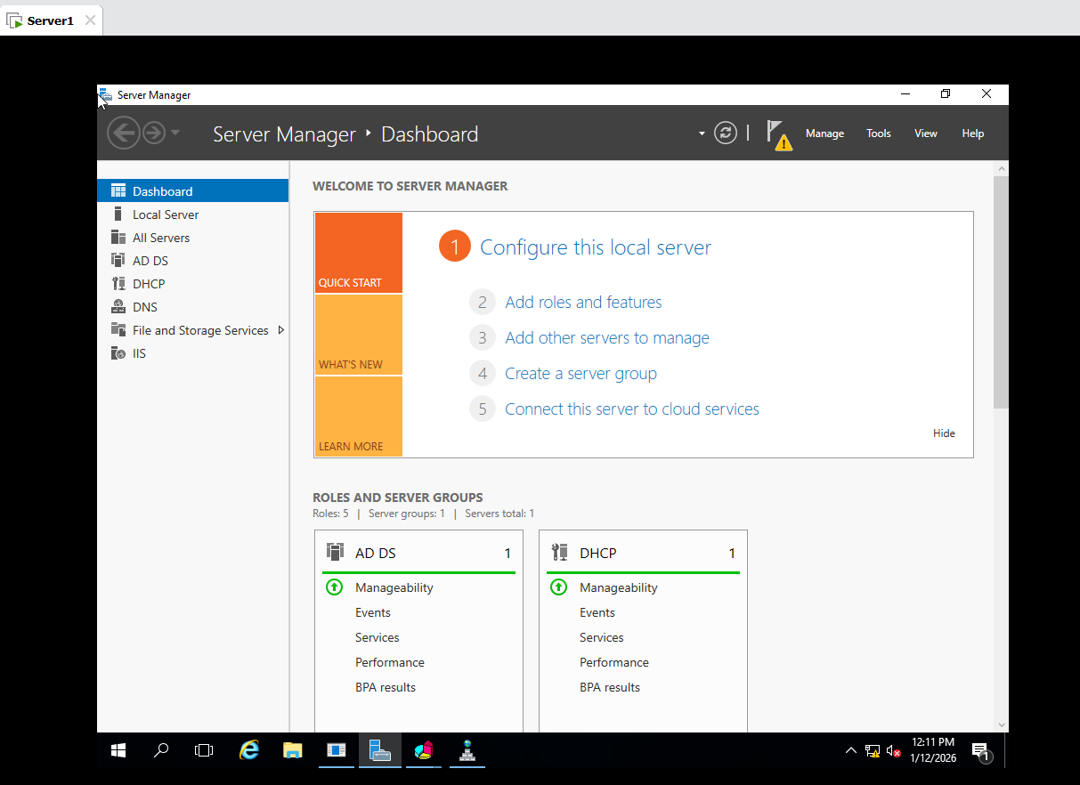
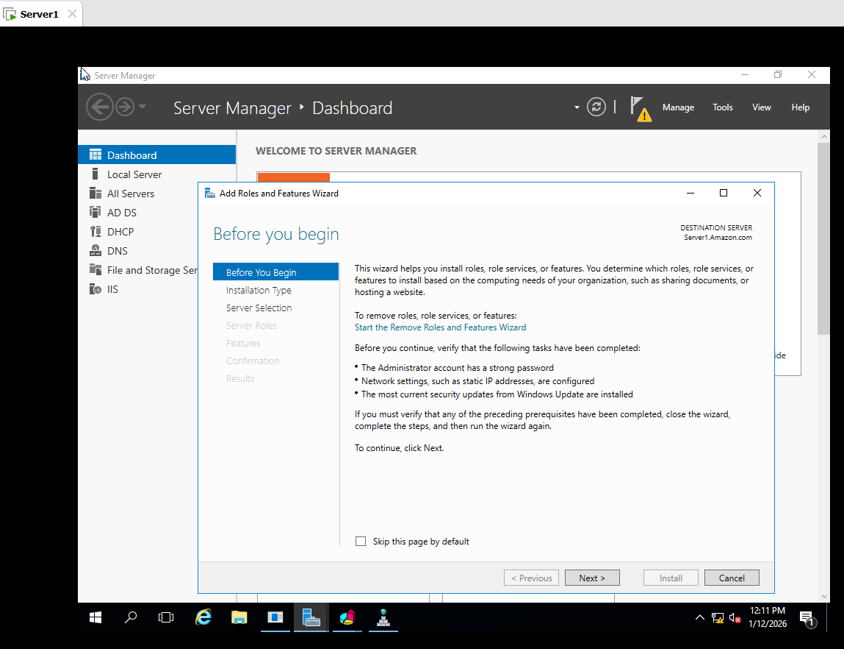
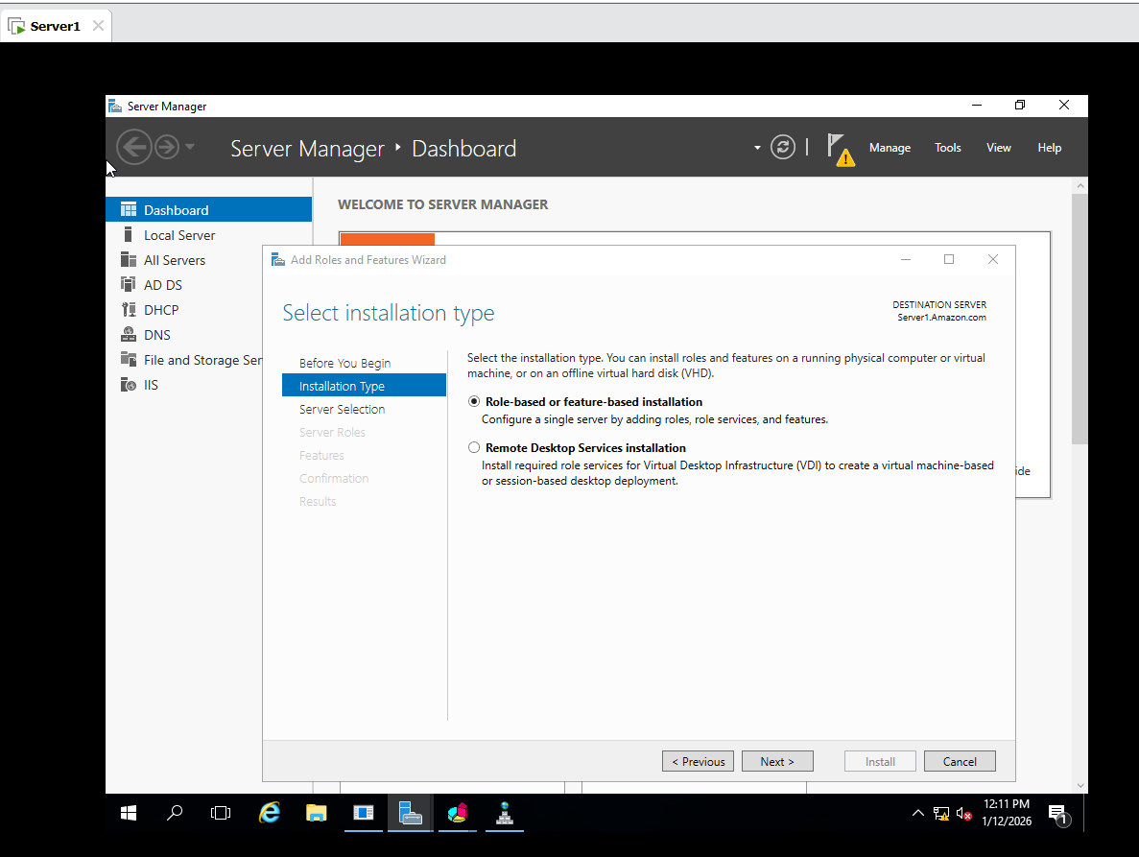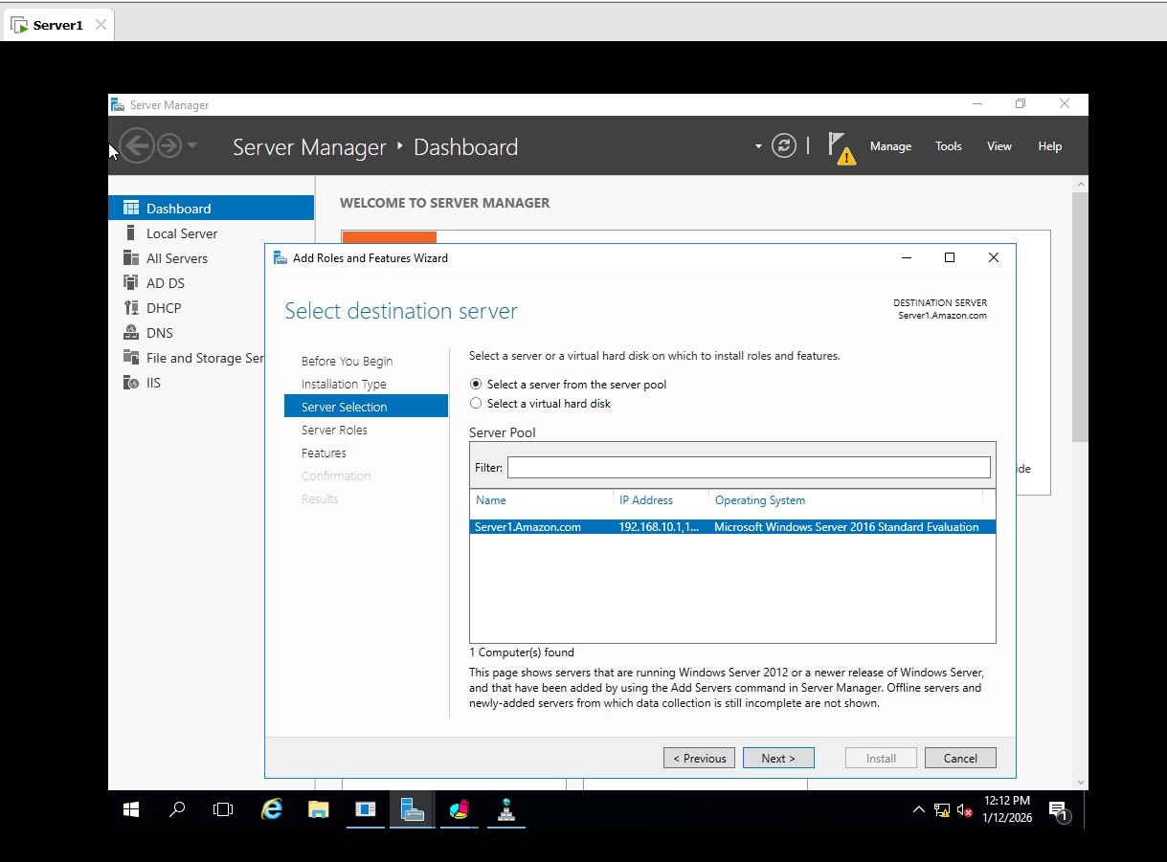

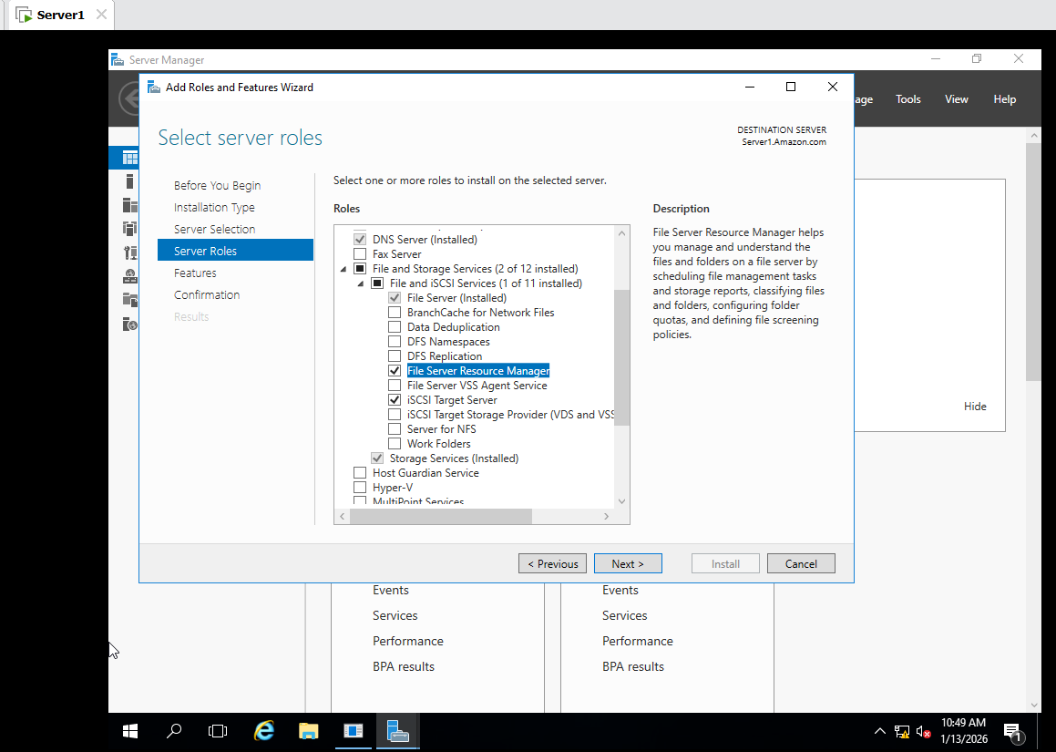
In Server 1 add a one Hard Disk SCSI Give 10 GB Power on Server 1 Computer Management Disk is Created then simple volume next formate Disk
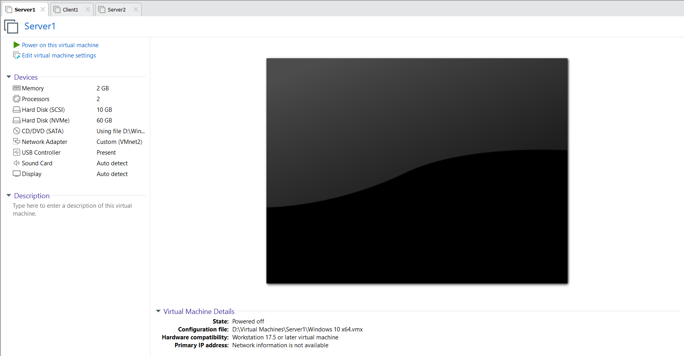
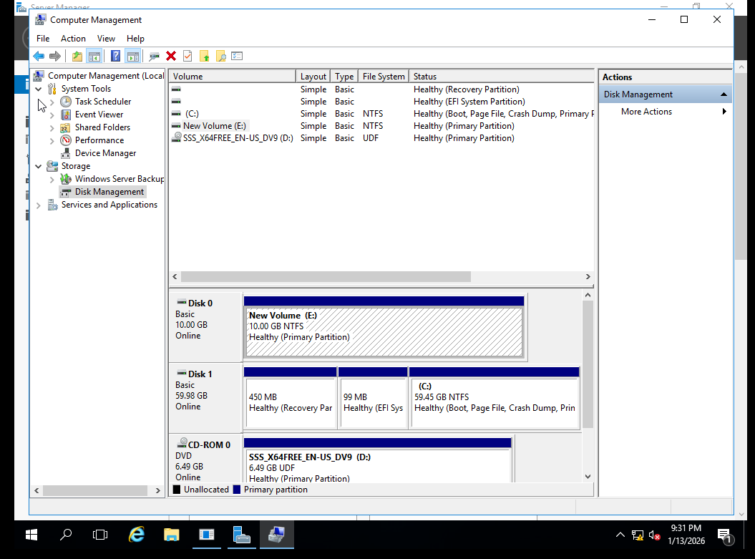
Dashboard Left Side show Files and Storage iscsi select by volume Show in that C and E
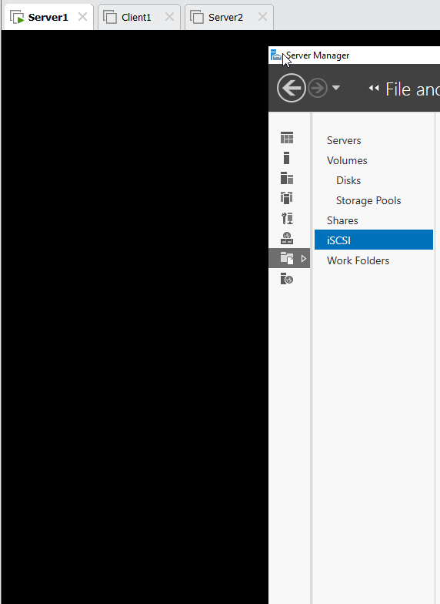
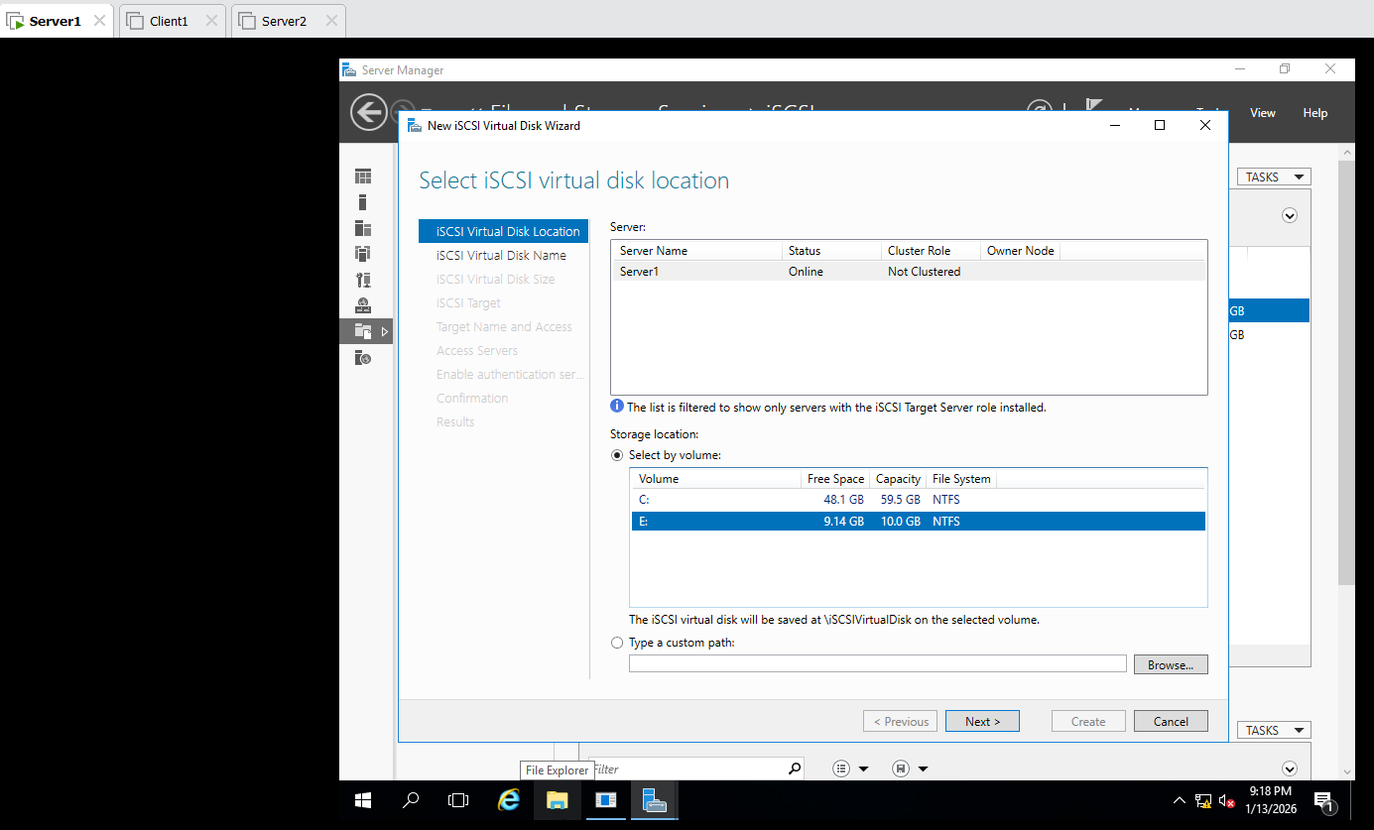
Select E drive next give name iscsi next give size 5 GB Select New iscsi target Select ip address 192.168.10.3 next Create
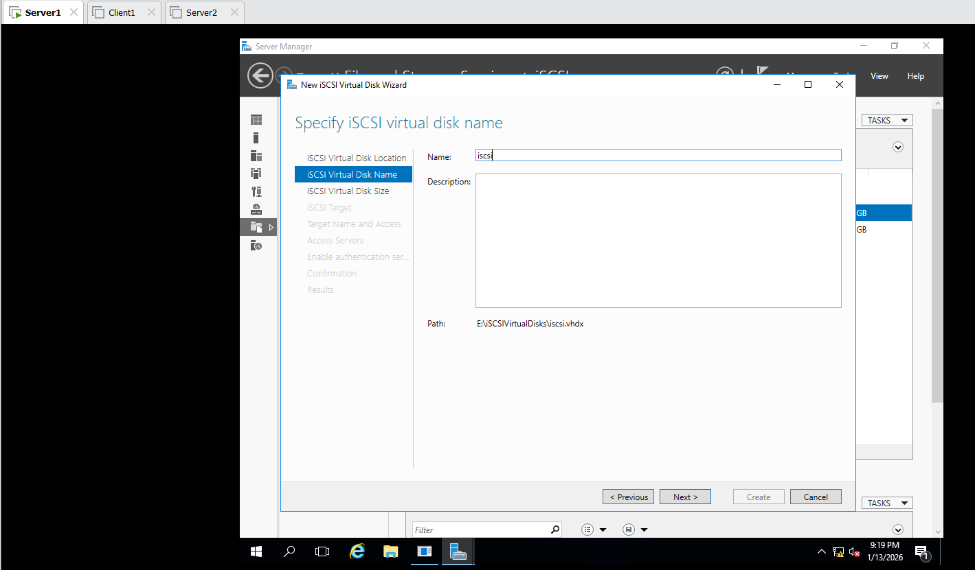
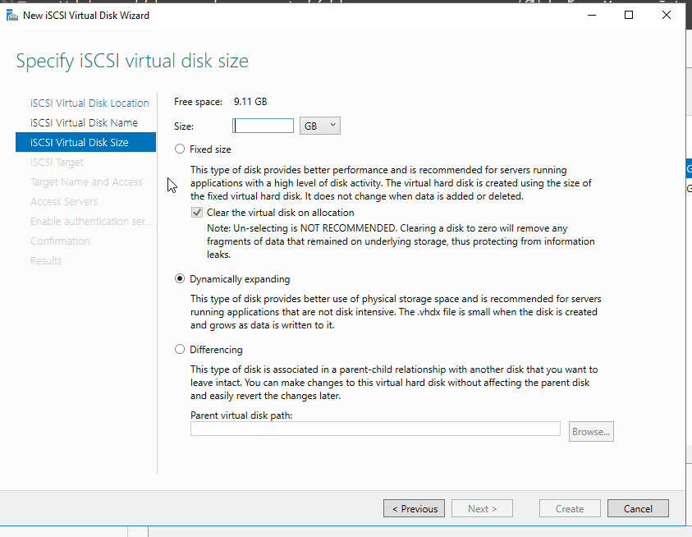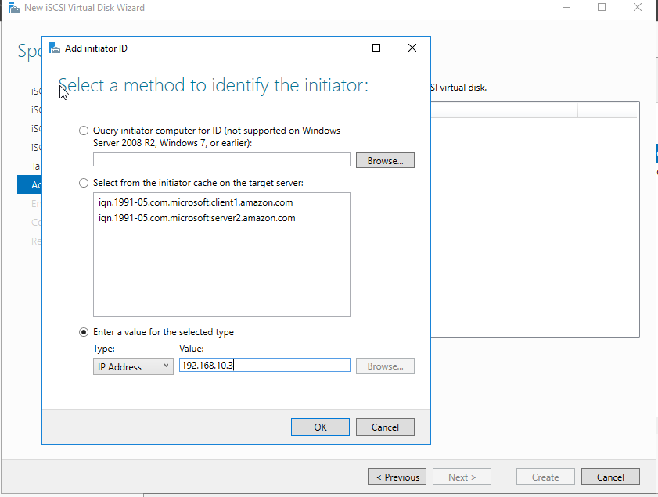
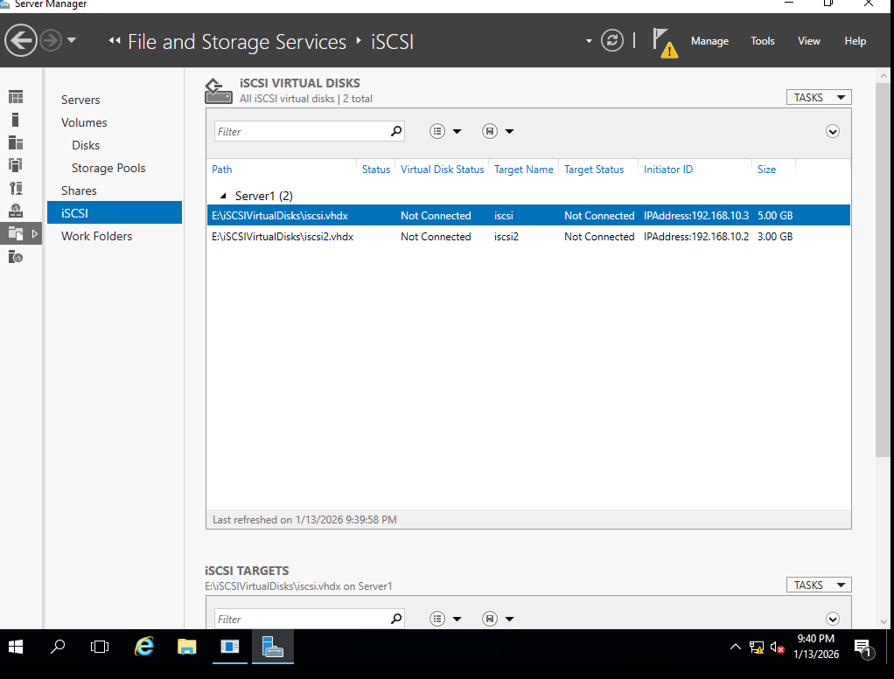
Client 1 :
- Computer Management Select MBR Simple Volume next .
- Search iscsi initiator give Target 192.168.10.1 connect ok
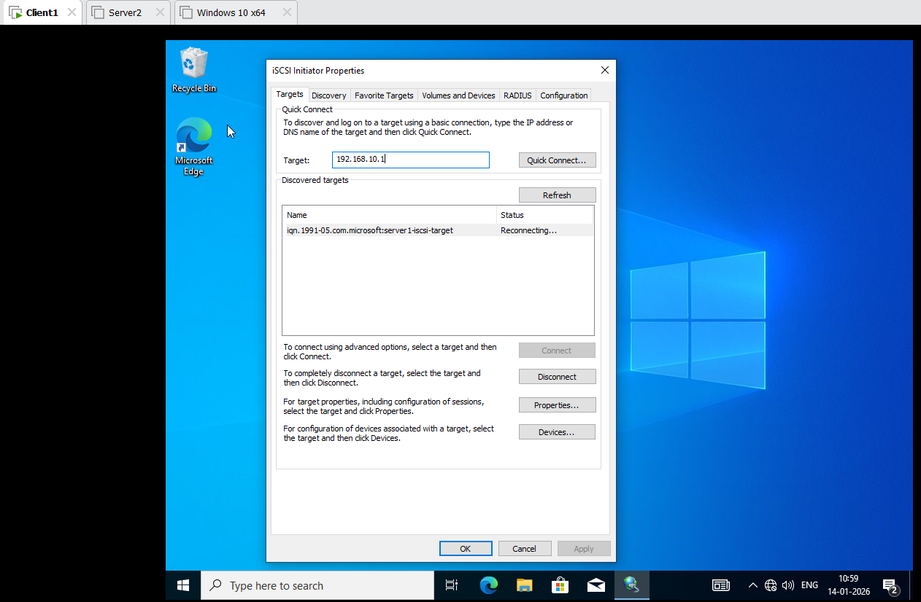
In Server 1:
iscsi Client 1 show Connected
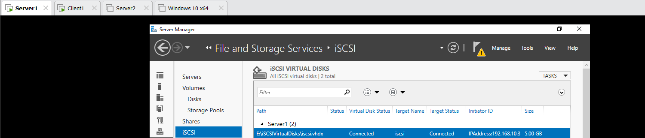
Task:
Same For Server 2:
Select E drive next give name iscsi2 next give size 2 GB Select New iscsi target Select ip address 192.168.10.2 next Create
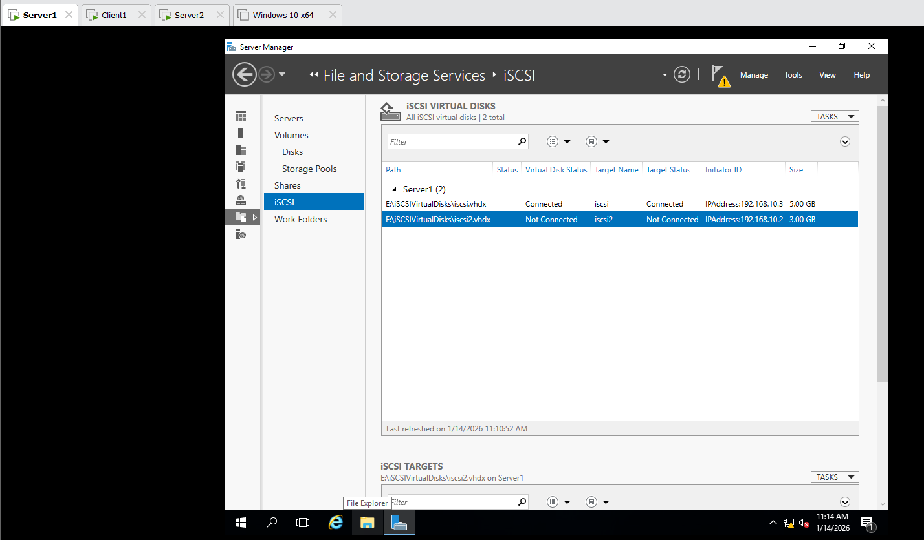

In Server 2:
- Computer Management Select MBR Simple Volume next .
- Search iscsi initiator give Target 192.168.10.1 connect ok
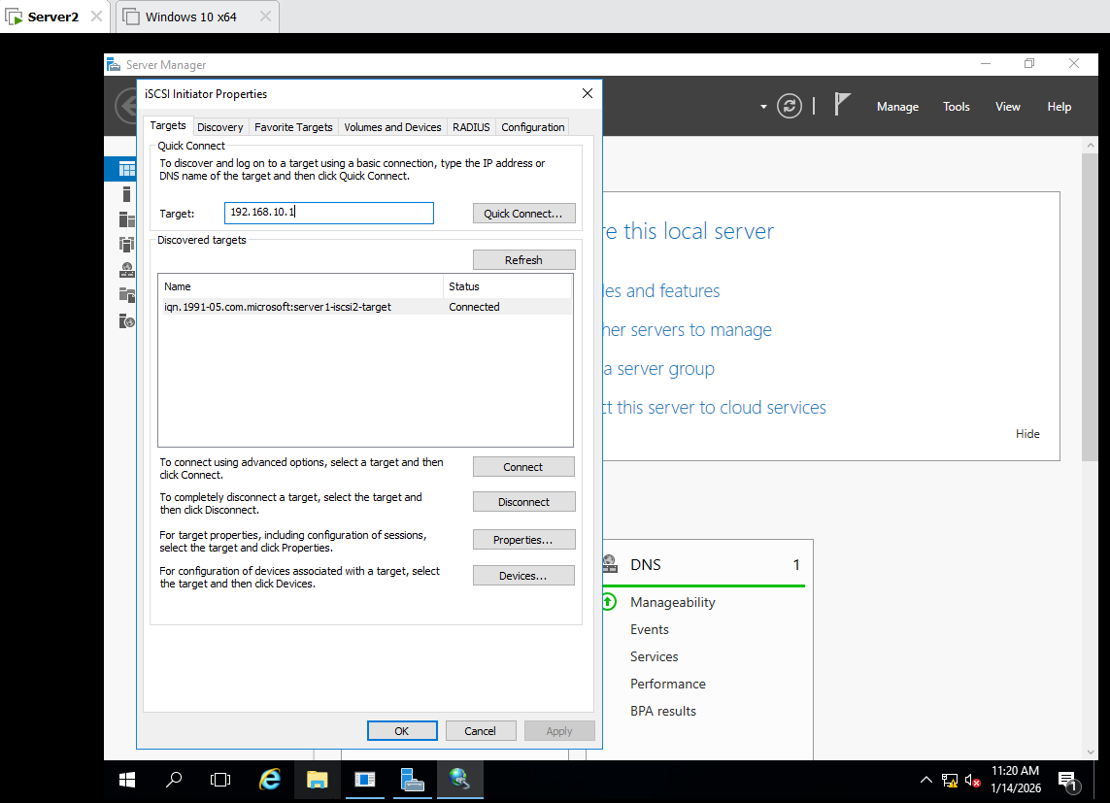
In Server 1: iscsi Server2 show Connected
